Rittal AX IT Nano DC
The new bodyguard for industrial data centres
Herborn, 3 April 2024
The march of IT technology into industry due to data-driven manufacturing processes continues unabated. Data centres are moving ever closer to production lines. Rittal has now made the interior of its robust AX compact enclosures ready for IT to protect sensitive IT systems like servers and switches in harsh industrial environments. The result is the new Rittal AX IT Nano Data Center (DC), a genuine bodyguard that offers high protection for the small data centres being used in industry.

While traditional data centres are located in security rooms or other protected environments, their use in direct industrial environments is a real challenge. Mini data centres in decentralised applications are exposed to harsh influences such as heat, dust or moisture. To protect sensitive servers and switches, robust enclosure technology is already established in the industry, offering a high degree of protection, 19" installation technology and numerous climate control options.
Rittal has now improved its AX compact enclosure to satisfy precisely these demands. With the new AX IT Nano DC, several servers can now be installed vertically to save space and then operated safely in line with strict industry standards such as IP56. Since the enclosure features a 19" mounting swing frame, installation and access to the servers is easy, despite the compact design.

The compact enclosure is equipped as standard with a pre-assembled fan-and-filter unit on the door to ensure a comfortable environment for the servers and switches. Should higher heat loads need to be dissipated, cooling units from the wide-ranging Rittal system range can also be integrated as required. Two lockable AX security locks at the top and bottom of the door ensure maximum access protection. The AX IT Nano DC from Rittal is available from stock as a wall-mounted and floor-standing enclosure in two sizes: 600 x 800 x 400 mm and 600 x 1000 x 400 mm (W x H x D).

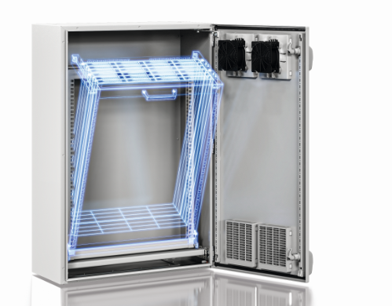
With the new AX IT Nano DC, several servers can now be installed vertically to save space and operate safely in line with strict industry standards like IP56.

May be reproduced free of charge. Please name Rittal GmbH & Co. KG as the source.

Rittal

Rittal is a leading global supplier of enclosure systems, automation and infrastructure with its industrial, IT, energy and power, cooling and service units. Rittal products and solutions are used in over 90% of global industries – standardised, customised, and always of the very best quality.
Our approach and methodology: Rittal, Rittal Software Systems (Eplan, Cideon) and Rittal Automation Systems (RAS, Ehrt, Alfra) combine their hardware and software expertise to streamline, optimise and digitalise processes across the entire value chain for our customers including their IT infrastructure – from control and switchgear construction, machine building to factory operators or the energy sector.
Our delivery promise: Rittal standard products are delivered in Germany within 24 hours, and within 48 hours throughout Europe.
Customer focus
Improving efficiency and increasing productivity through automation and digitalisation is one of the biggest challenges for our customers. This requires in-depth knowledge and expertise, the combination of hardware and software, and cross-sector networking. We are convinced that creating and connecting data rooms is crucial to the success of industrial transformation. And that is exactly our speciality and field of competence.
Eplan and Rittal are driving the development of the digital automation twin, making data accessible and useable in operations as well. Cideon is improving data consistency in the digital product twin context with its CAD/CAM, PDM/PLM and product configuration expertise.
Sustainability
Environmental and climate protection, social commitment and ethical corporate management are a given for Rittal. We take our responsibility for a sustainable future seriously. Our approach to resource management and conservation involves continuous improvement of our own production processes and ensuring that our products have the lowest possible Product Carbon Footprint. Our solutions support our customers in achieving their own climate targets.
Family business and global player
Founded in 1961, Rittal is the largest company in the owner-operated Friedhelm Loh Group. The group operates worldwide, with 12 production sites and 95 international subsidiaries. It has 12,100 employees and posted revenues of 3 billion euros in fiscal 2023. In 2023, the Friedhelm Loh Group was presented with the “Best Place to Learn” and “Employer of the Future” awards. In 2024, Rittal was awarded the Top 100 Seal as one of Germany’s most innovative medium-sized companies for the third time in a row.
For more information, visit www.rittal.com and www.friedhelm-loh-group.com.

Corporate Communications
Dr. Carola Hilbrand Rittal GmbH & Co. KG
Corporate & Brand Communications Auf dem Stützelberg
Phone: +49 (0)2772/505-2527 35745 Herborn, Germany
hilbrand.c@rittal.de www.rittal.com

